Calculating Site Energy Use Intensity (EUI) for the AIA Common App

Overview
This document provides instructions on how to complete the “Measure 5 - Design for Energy” section of the AIA Common App for Design Excellence (AIA Common App) based on data generated by California compliance software for the building project. Post-processing of compliance software output data will be required. Instructions and a simple calculator are provided to perform the post-processing calculations.
The Title 24 Energy Standards are updated every three years, so there will be different code requirements and different compliance software outputs and reports depending on when the building went for permit. Different software is approved for low-rise residential buildings (single family and 3 story or less multifamily) versus nonresidential and high-rise residential buildings.
This document provides instructions to perform the appropriate calculations on data from reports generated by several versions of the CA compliance software. Click the links in the table of contents below for instructions relevant to your project’s code vintage.
These instructions apply to nonresidential and high-rise residential buildings only. Instructions for low-rise residential projects are provided in a separate document.

Table of Contents:
- Quick Primer on EUI Metrics
- Instructions for Calculating Site Energy
  - Gather General Project Data
  - Gather Energy Use Data
    - 2013 Title 24 Standards (permit application dates between July 1, 2014 - December 31, 2016)
    - 2016 Title 24 Standards (permit application dates between January 1, 2017 - December 31, 2019)
    - 2019 Title 24 Standards (permit application dates after January 1, 2020)
  - Enter Data into EUI Calculator
- Instructions for Filling Out the AIA Common App
- Reference - EUI Calculation Formulas

Quick Primer on EUI Metrics

Site Energy vs. TDV Metrics
The unit of energy for the performance method compliance software is called Time Dependent Valuation (TDV) energy. It is reported as annual energy use per square foot in kBtu/ft²-yr, sometimes abbreviated to kTDV/ ft²-yr. The concept behind TDV is that energy efficiency measure savings should be valued differently depending on which hours of the year the savings occur, to better reflect the actual costs of energy to consumers, to the utility system, and to society. Thus a TDV multiplier is applied to modeled energy use for each hour of the year. This approach is consistent for all of the Title 24 Part 6 compliance software for 2013, 2016 and 2019, although different multipliers are used for each code cycle.
However, site energy is NOT the same as this compliance-only TDV metric (even though it also uses units of kBtu/ft²-yr) . In order to report site energy EUI, be sure to use the right energy metrics. The instructions below will point you to the correct data.

One More Thing About Metrics
Site energy metrics are often reported in units associated with a specific fuel type. For example, electricity consumption is often reported in kWh or MWh. In order to calculate site energy EUI, unit conversion is needed to translate energy consumption to kBTU. These calculations are all handled in the calculator tool. See the reference section at the end of this document for details on all of the calculation formulas.

Instructions for Calculating Site Energy

1. Gather Data from Compliance Form NRCC-PRF-01-E
The NRCC-PRF-01-E form is created by all approved nonresidential compliance software in CA. If your project ran a Title 24 model, you will have this form! Some software tools produce additional supporting reports, but the NRCC-PRF-01-E is the official form used for permitting when following the performance compliance path.
The 2013 and 2016 compliance forms are very similar. While there are some small differences between the forms, the data on both versions relevant to the AIA competition is identical. The 2019 Standards brought significant revisions to the compliance forms, so instructions for 2019 projects are called out separately, where appropriate.

1a. Gather General Project Data
This process applies to the forms for all three code cycles:

2013 Title 24 Standards
(permit application dates between July 1, 2014 - December 31, 2016)

2016 Title 24 Standards
(permit application dates between January 1, 2017 - December 31, 2019)

2019 Title 24 Standards
(permit application dates after January 1, 2020)

Table A on page 1 of the NRCC-PRF-01-E form contains general project information. Make note of the following values (highlighted below):
- Total Conditioned and Unconditioned Floor Area - these values are used to calculate the project’s total floor area and are needed for the EUI calculation
- Climate Zone - not needed for the EUI calculation, but it is a required input in the AIA form.
- Standards Version - not needed for the EUI calculation, but it is a required input in the AIA form.
An example of Table A is shown below in Figure 1.
Figure 1 - NRCC-PRF-01-E, Table A (applies to 2013, 2016, 2019)

1b. Gather Energy Use Data
This process is the same for the 2013 and 2016 Title 24 forms, but differs for 2019. For 2019 code projects, skip ahead to the next section.

2013 Title 24 Standards
(permit application dates between July 1, 2014 - December 31, 2016)

2016 Title 24 Standards
(permit application dates between January 1, 2017 - December 31, 2019)

Table B on page 1 of the NRCC-PRF-01-E form shows the compliance results but these values are reported in the TDV metric, NOT site energy. DO NOT USE DATA FROM Table B!!!
An example of Table B is shown below in Figure 2.
Figure 2 - NRCC-PRF-01-E, Table B (applies to 2013, 2016)

Site energy is reported in Table U of the NRCC-PRF-01-E form. Values needed to calculate site energy EUI are highlighted below in Figure 3.
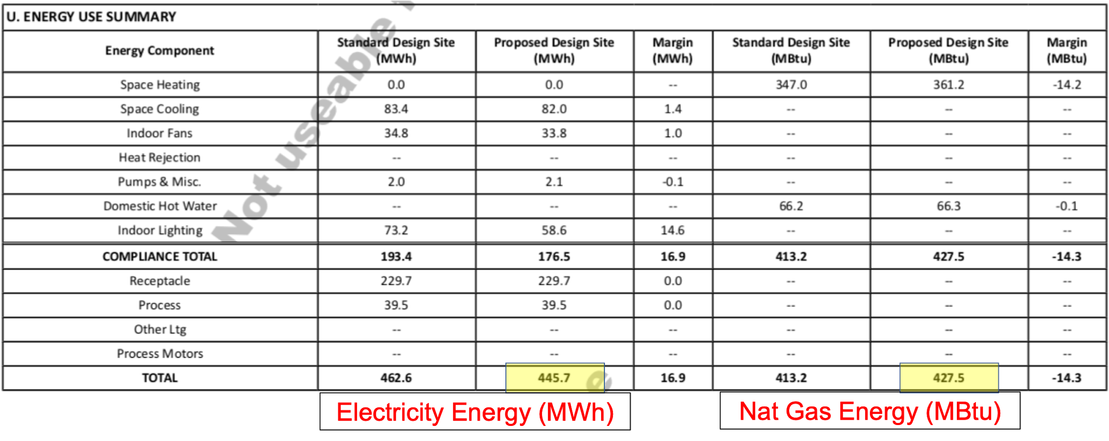
Figure 3 - NRCC-PRF-01-E, Table U (applies to 2013, 2016)

2019 Title 24 Standards
(permit application dates after January 1, 2020)

Table C1 on page 2 of the NRCC-PRF-01-E form shows the compliance results but these values are reported in the TDV metric, NOT site energy. DO NOT USE DATA FROM Table C1!!!
An example of Table C1 is shown below in Figure 4.
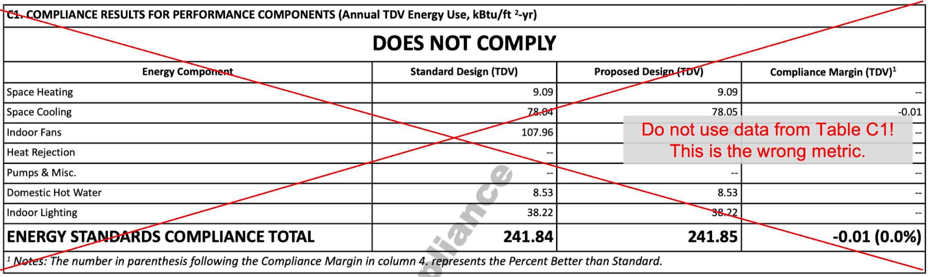
Figure 4 - NRCC-PRF-01-E, Table C1 (applies to 2019)

Site energy is reported in Table C3 of the NRCC-PRF-01-E form. Values needed to calculate site energy EUI are highlighted below in Figure 5.
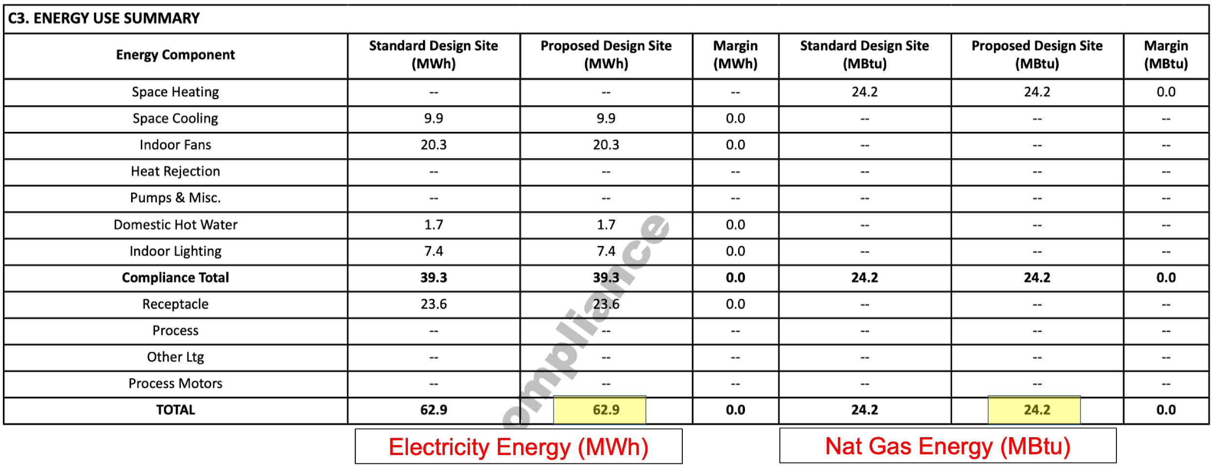
Figure 5 - NRCC-PRF-01-E, Table C3 (applies to 2019)

2. Enter Data into EUI Calculator
Enter the following values into the EUI calculator:
Gross EUI - Enter the building area and site energy consumption values from the Title 24 reports into the calculator tool to calculate the building’s gross EUI. Gross EUI represents a building’s total annual energy consumption per square foot of building area.
Net EUI - This is an optional table for projects that generate renewable energy. Net EUI represents a building’s total annual energy consumption minus annual energy generated per square foot of building area. If there is no renewable energy generation on your project, enter “0” for annual production and the Net and Gross EUI values will be the same.
Note: The renewable production input value is not reported on Nonresidential Title 24 compliance forms and must be calculated using a separate analysis. Consult the AIA competition guidelines for guidance on how to account for renewable generation.
An example of the calculator’s inputs and outputs is shown below in Figure 6.

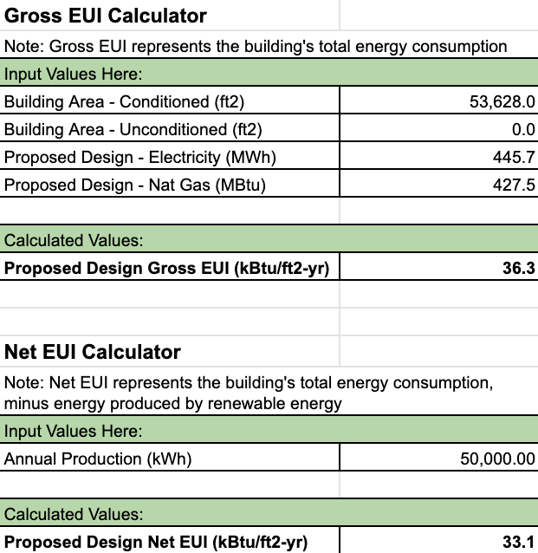
Figure 6 - EUI Calculator Example

Instructions for Filling Out the AIA Common App
Use the values generated by the calculator tool and from the compliance forms to fill in the highlighted portions of the AIA Common App for Design Excellence according to the instructions below.

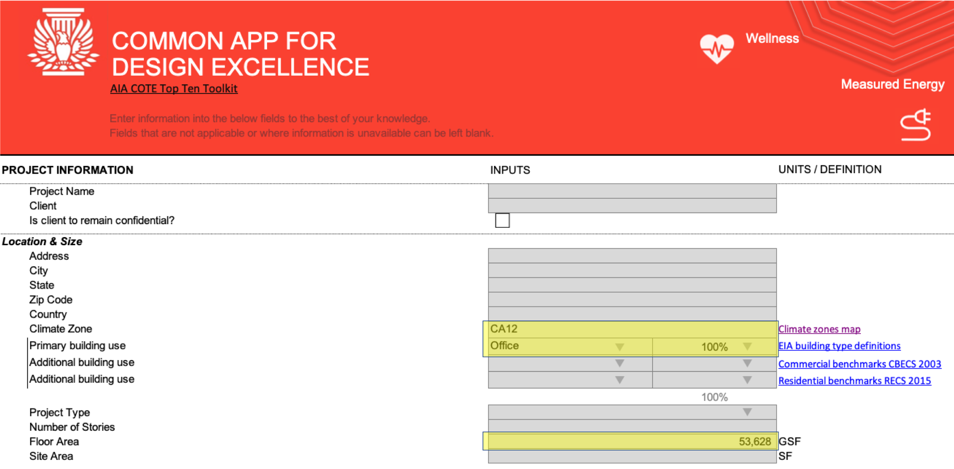
Figure 7 - AIA Common App: “Project Information”

Project Information - Input Descriptions:
The following inputs are used to calculate your project’s Benchmark EUI for the 2030 Challenge.
- Climate Zone: Select your project’s California climate zone from the drop-down menu. This value should be taken from Table A of the compliance form (refer to Figure 1 above).
- Primary building use: Select the building type from the drop-down menu that represents your project’s primary use. If this is the only use of the building, select “100%” from the adjacent cell in the form. For mixed-use buildings, select an appropriate percentage of building floor area for this building use type, and then define “additional building use(s)” and corresponding percentage of floor area for these additional uses. Note: this information is not reported on the Title 24 compliance forms, but should be available from the project design team.
- Floor Area: Enter your project’s floor area, which is the sum of conditioned and unconditioned floor areas from Table A of the compliance form (refer to Figure 1 above).

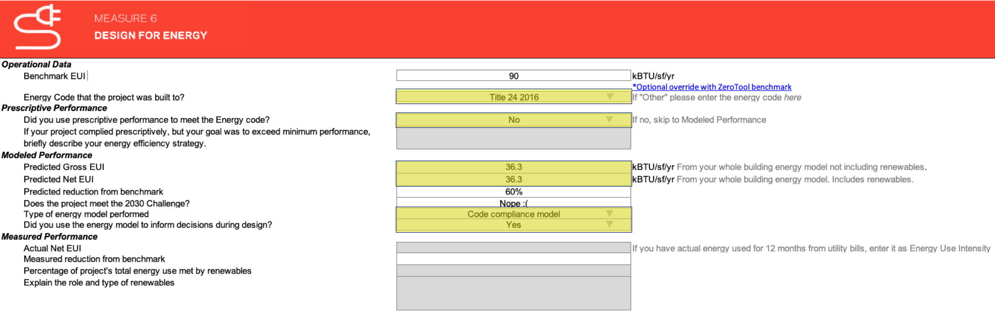
Figure 8 - AIA Common App: “Measure 6 - Design for Energy”

Design for Energy - Input Descriptions:
In this section, enter additional data in the highlighted fields. Your project’s energy performance will be compared against the 2030 Challenge Benchmark EUI.
- Benchmark EUI: This is not an input value - it is automatically calculated based on the building type and climate zone inputs in the “Project Information” section of the AIA form. Your project’s EUI will be compared against this benchmark to determine if it meets the 2030 Challenge.
- Energy Code that the project was built to?: Select the appropriate version of the energy code from the drop-down menu. This value should be taken from Table A of the compliance form (refer to Figure 1 above).
- Did you use prescriptive performance to meet the energy code?: Select “No” from the drop-down menu.
- Predicted Gross EUI: Enter your project’s Proposed Design Gross EUI as calculated by the EUI Calculator.
- Predicted Net EUI: Enter your project’s Proposed Design Net EUI as calculated by the EUI Calculator.
- Predicted reduction from benchmark; Does this project meet the 2030 challenge?: These are not input values - they are automatically calculated based on a comparison of the Benchmark EUI to the Predicted Net EUI.
- Type of energy model performed: Select “Code compliance model” from the drop-down menu. Note: if your project also utilized another energy model (e.g. for LEED or design decision making), you may select “Energy performance model”; however, the input values from an alternate (non-compliance) model will come from a different set of reports and instructions are not included in this document. Please consult the project’s energy modeler.
- Did you use the energy model to inform decisions during design?: If your project used multiple energy modeling iterations to select or refine design features with a goal of reducing energy or meeting a specific performance target, select “Yes. ” If a single compliance model was run to document the project’s performance or if iterations of the model were primarily focused on passing the code requirements, select “No.”

Reference - EUI Calculation Formulas
The following formulas are used by the calculator tool to calculate site energy EUI:

Convert Electricity MWh to kBTU:
$${Elec}_{kBTU}={Elec}_{MWh} * 3,412$$
Convert Natural Gas MBtu to kBTU:
$${Gas}_{kBTU}={Gas}_{MBTU} * 1,000$$
Calculate site EUI:
$$EUI=({Elec}_{kBTU} + {Gas}_{kBTU}) / ({FloorArea}_{conditioned} +{FloorArea}_{unconditioned})$$
Calculate Percent Improvement:
$$\% Improvement=({EUI}_{Standard} - {EUI}_{Proposed}) / {EUI}_{Standard}$$

Acknowledgements
This document and the EUI calculator were developed by Model Efficiency on behalf of AIA CA and Pacific Gas and Electric’s Pacific Energy Center.

PVWatts is a popular tool used for estimating annual energy generation from solar PV systems.

