
College of Fellows
California Representative Bio

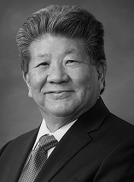  Southern CA  Regional Rep.  Michael Enomoto, FAIA | Michael. A. Enomoto, FAIA is the Managing Partner at Gruen Associates. Best known for his significant practice as an Executive Architect in collaboration with Design Architects across the world, Enomoto has led landmark projects of various sizes and types totaling over $1.5 billion in construction costs, including the Los Angeles Convention Center and the US Embassy in Berlin. A graduate of Cal Poly, SLO, Enomoto was the 2007 AIA/LA President, the 2013 AIA California President, the 2010 President of the Southern California Development Forum, the 2001 to 2003 President of the Asian American Architects/Engineers Association and served on the City of Los Angeles Quality and Productivity Commission. He was the 2018 AIA Los Angeles Chapter Presidential Gold Medal Awardee, the highest award given by AIA/LA.

